**SOCKET PROGRAMMING ASSIGNMENT- 2:**

Here is a thread, which is present in server and client both, and it continuously listens for the message. The client thread listens for any message coming from server and Server thread waits for Clients message:  
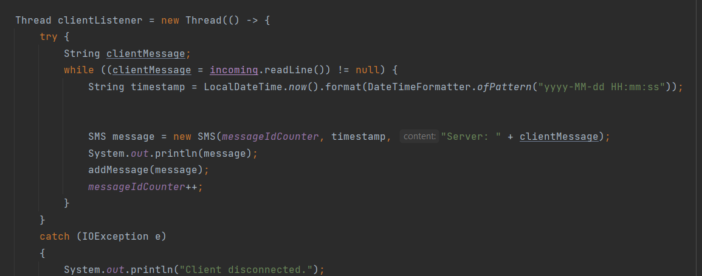

Here is the User Control Manual, both server and client ends have access to this:

When someone from Server chooses operation 1 i.e. Send a message, the Client end receives that message and stores it in a separate array:  
Message from Server:

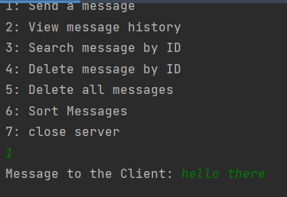

Message received at Client end:

Here we send Reply back to our Server from Client: (Server received this message)  
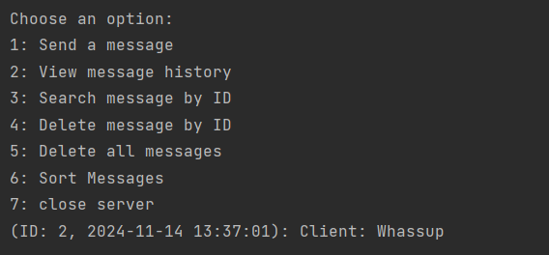

Here is the full conversation history:  
